Port Weller Parent Council Meeting
April 27, 2021

Attendees: Jason, Kevin Dyck, Natalie, Jodi, Elizabeth, Stephanie, Patti, Jess
Next Meeting: May 25, 2021
Action:
- PC - send feedback on the door
- PC if having an opinion on who should be able to initiate a renaming of a school

AGENDA:
- Principal Update- Mr. Jason Clarke:
Door Wrap
- First revision based on feedback has come back
- Staff and School Council can email feedback to me
- Mr. Dyck to share history/context for door wrap concept

Staff:
- Mrs. Chilcott has returned
- Leo's last day was April break, at Orchard Park as a location closer to home. Our caretaker posting is currently open.
- Mrs.Flight is currently filling in for Mrs.Perrier’s class
Return to Virtual Learning
- Pretty smooth start…parents have been supportive…good student participation
- Have loaned about 46 devices to families
- Thanks to Carleton for lending us additional tech

DreamBox Challenge
- It was fun and successful
- Prizes – frozen treat for class winners & math puzzle/game for individual winners
- I decided to recognize/reward additional students for excellent work over the 4-week challenge

Library Design Update
- Ordered $26 000 of furniture from Schoolhouse Products
- New cabinets have been installed…mural painted over
- Ordering $5600 of Book display carts…our Superintendent is willing to help with funding
- Interactive Smart technologies board being installed
- Mr. Thorpe to purchase additional books/resources as needed once we put everything into place

Student Census Survey
- Gr 7-12: March 22-April 1 (was completed in class)
- K-6 Survey April 6-30 (done at home)
- K-6 Staff will send a reminder this Wednesday to parents

Autism Awareness Day (April 6)
- Mr. Neufeld’s FSP students created an amazing bulletin board with whole school contributing
- Michael Jacques gave 2 amazing presentations connected to his books
- K-4 & FSP - “I Belong, Can I Play” with Heather Gale reading
- 5-8 & FSP – Can’t Read, Can’t Write, Here’s My Book
- Purchased 10 copies of each book library/classrooms
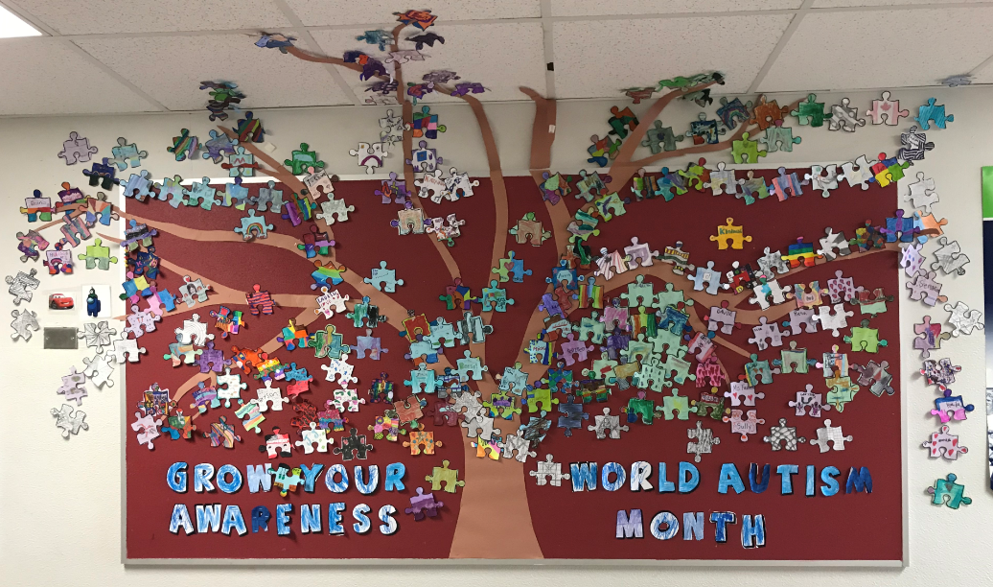

Picnic Tables Ready to be Delivered
- Tables have been build & stained
- Cheque has been delivered…just working out logistics for delivery.
- Cost was higher than originally thought due to increase in price of lumber
- School will pay the additional cost as well as delivery fee

Policy A-09 Naming/Renaming of Schools
- The DSBN Policy is under review and revisions are being made to possibly address a third pathway for considering the name of a school.
- Senior team is looking for feedback

Financial Report:

Purchasing:
- Natalie able to secure 5 kits - higher level books - 200 books for $1800
- $500 approved to move forward for a budget of books of inclusivity - Mr.Thorpe to control

Fundraiser:
- Potential trying plantables next year - Elizabeth to test it out

