
Happy Easter Pirate Families!

The month of April is going to fly by with Easter the first weekend and then Spring Break the third week. I hope that all of our families are able to find the time during the holidays/break to safely get outside and make the most of the weather. We have been cooped up for a long time. It is so important for us to make that time to get in a little exercise – it will do the mind and body good!
Your children are working diligently on their learning each day which is sometimes difficult with all the COVID restrictions (e.g., mask wearing, social distancing, lack of group work). However, each day we are impressed with their ability to focus on the task at hand and do their best with the activities assigned. We know that it has not been a year of exciting co-curricular events, but we are doing our best to allow them to enjoy their learning and each other’s company every day. Special events this month like World Autism Day, Earth Day, Trivia Tuesdays, and our Weekly Spirit Days will certainly be highlights. Please continue to support your child in their learning at home by encouraging them to read every day.

WELCOME BACK MRS CHILCOTT!!
We are so excited to be welcoming Mrs. Chilcott back to the Pirate Ship on Tuesday April 6! Mrs. Chilcott will be co-teaching with Miss Parker for the next several weeks. I know she is SUPER excited to see all her Grade 3 students and she can’t wait to collaborate with Miss Parker to create amazing learning experiences for our Grade 3 students!

IMPORTANT DATES TO REMEMBER:
Good Friday: Friday, April 2nd (holiday/no school)
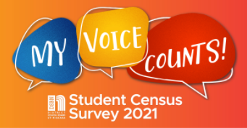
Easter Monday: Monday, April 5th (holiday/no school)
Spring Break: Monday, April 12th to Friday, April 16th (no school)
First Day Back from Break: Monday, April 19th.

DSBN STUDENT CENSUS SURVEY - March/April
Earlier this week our grade 7 & 8 students along with students across the DSBN completed the DSBN Student Census Survey with their teachers. From April 6 to 30, we are asking all parents with students in JK to grade 6 to complete the Student Census Survey online. You can access the survey on the Port Weller website. https://portweller.dsbn.org/


WORLD AUTISM AWARENESS DAY – Please wear blue on Tuesday, April 6, as the DSBN will be celebrating World Autism Day. Students will be discussing autism in their class and celebrating the uniqueness of autistic people. Additionally that week we will enjoy 2 virtual presentations from Michael Jacques, a local author who has Autism.
STUDENTS RETURNING TO IN PERSON LEARNING – April 19
Recently, parents of students who have been learning online were given their final opportunity to return to in person learning at their home school. We are so very excited to be welcoming back to Port Weller several of our students who have been learning online for most of the year. We are also fortunate that the addition of our new/returning Pirates will not bring about any restructuring of classes. I know that staff and students alike are eager to reconnect with students we’ve been missing for many months.


EARTH DAY - April 22
Every year, we celebrate Earth Day by doing a variety of activities in our classrooms and outdoors. We limit our use of lighting, clean up the school yard and sometimes even plant something. This year will be slightly different, but a variety of activities will continue as we celebrate Mother Earth

SCHOOL COUNCIL FUNDRAISERS

A huge thank you goes out to those families who supported our Make Your Own Pizza Fundraiser. We raised around $350 for our students! A big SHOUT OUT to our School Council and Scorecard Harry’s for making this happen.
Be on the lookout for a Spring Flower Fundraiser in the very near future where we once again team up with Niagara College Greenhouses.

PICNIC TABLES ON THE WAY

We have just placed an order to have six 8-foot picnic tables build by a local small business. These tables will be placed in the south west field area (between the Gym and the Lions Field) and will be used as an additional outdoor classroom space that can be accessed by any of our classes. A HUGE thank you goes out to our School Council, for paying for the tables. They should be ready in a few weeks.


WATER BOTTLES
Please ensure that your child brings their labelled water bottle to school so they can keep hydrated as the weather warms up. Although our fountains have been turned off, our 2 water hydration stations are always accessible.

GRADE 8 GRAD PHOTOS

Edge Imaging is opening pop-up photo studios across the country, and they’ll be hosting a studio in St. Catharines at the BEST WESTERN HOTEL & CONFERENCE CENTRE from April 6-23 (this may be extended depending on demand)! Student health is our number one priority, so our photographers will be adhering to strict new COVID protocol. To book your appointment, visit edgeimaging.ca/popup or to find out more about Edge's safety protocols around COVID-19, visit edgeimaging.ca/faq.
DISMISSAL CONGESTION
As many of you are aware, the area in front of the Gym is a very busy place at the end of the day. With the nicer weather, we tend to get more parents walking to school for pick-up…and that is great! Please ensure that you are maintaining your physical distance from others especially if you have pets that accompany you. Additionally, once you have picked up your child(ren), if you could please make your way home promptly, we minimize the congestion and ensure everyone’s safety. Thanks for your help with this!

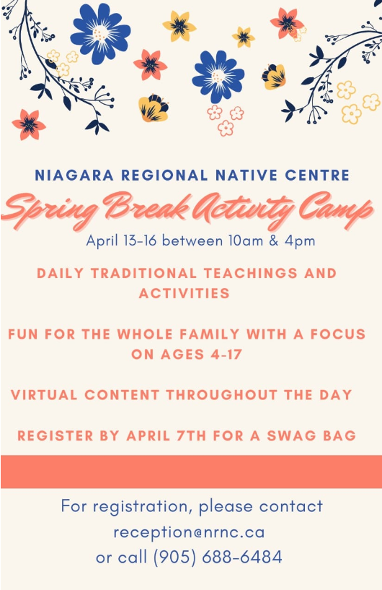
SPRING BREAK CAMPS OPPORTUNITIES
Niagara Regional Native Centre Spring Break Activity Camp
Do you want some family friendly activities on the Spring Break from school for your family? Connect with the Niagara Regional Native Centre to get an activity pack to enhance our virtual camp by calling 905-688-6484.
Each day will begin and end with a traditional teaching or story and include interactive and family friendly activities.
The camp will run from April 13th-17th. You don't have to register at all to participate, but if you want the activity bag please contact us by April 7th by calling 906-688-6484 or emailing reception@nrnc.ca

FREE opportunity for DSBN students grades 3-7 only
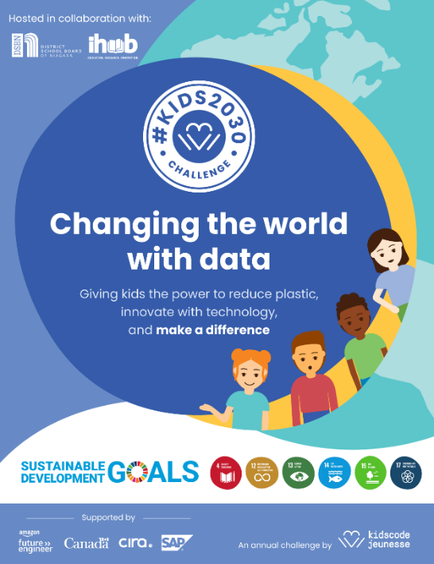
Join us for a great learning experience with Kids Code Jeunesse this Spring Break. This online opportunity runs April 12 to 16 from 10:30 AM to 12:00 PM.
In this 5-day coding camp participants will learn how to use Scratch to program their own animations and games. The activities will focus on using code and data science to find solutions to the global plastic pollution problem. The camp will wrap up with a roundtable discussion on the impact plastic has on participants’ lives and the world around them.
***Campers are required to have individual access to a Chromebook/laptop and WiFi throughout the duration of the camp.***
Register here: https://forms.gle/jyCk8WNwUvJycuUn8

